Vpc challenges
Use Case: Setting up Transit Gateway and VPC Endpoints for a Multi-VPC Architecture
Scenario:
A large organization is migrating its on-premises infrastructure to the AWS cloud.
The organization's architecture involves multiple VPCs for different departments and applications, each requiring secure communication with centralized services and external resources.
The IT team needs to design and implement a scalable and efficient network architecture to accommodate the organization's growth and ensure robust connectivity between VPCs and external services.
- Configure VPC endpoints to securely access AWS services without internet gateways or NAT gateways, ensuring data privacy and minimizing exposure to external threats.

Go to vpc-->create VPC
create internet gateway-->attach to created VPC
create 2 subnets public and private
Go to vpc-->create VPC
create internet gateway-->attach to created VPC
create 1 subnets public and private
create 1 route tables public and private
edit route table for public-->add route 0.0.0.0/0 target internet gateway
create 2 ec2 instances public and private one with public subnet and one with private subnetconnect to public ec2 insatance
Go to root sudo su -
aws configure
crate IAM user and generate key and password
give the access key and password, region and format
use command "aws s3 ls" to see the s3 logs
create a file and paste the pem key of public instance
Now login with private instance ip with in the same server
use command "aws s3 ls"-->command will not excuste because we have created any endpoint.Go to endpoint service create endpoint by selecting gteaway, adding s3-service-region, vpc and route table to private.check in CLI with "aws s3 ls" the s3 logs will be available.

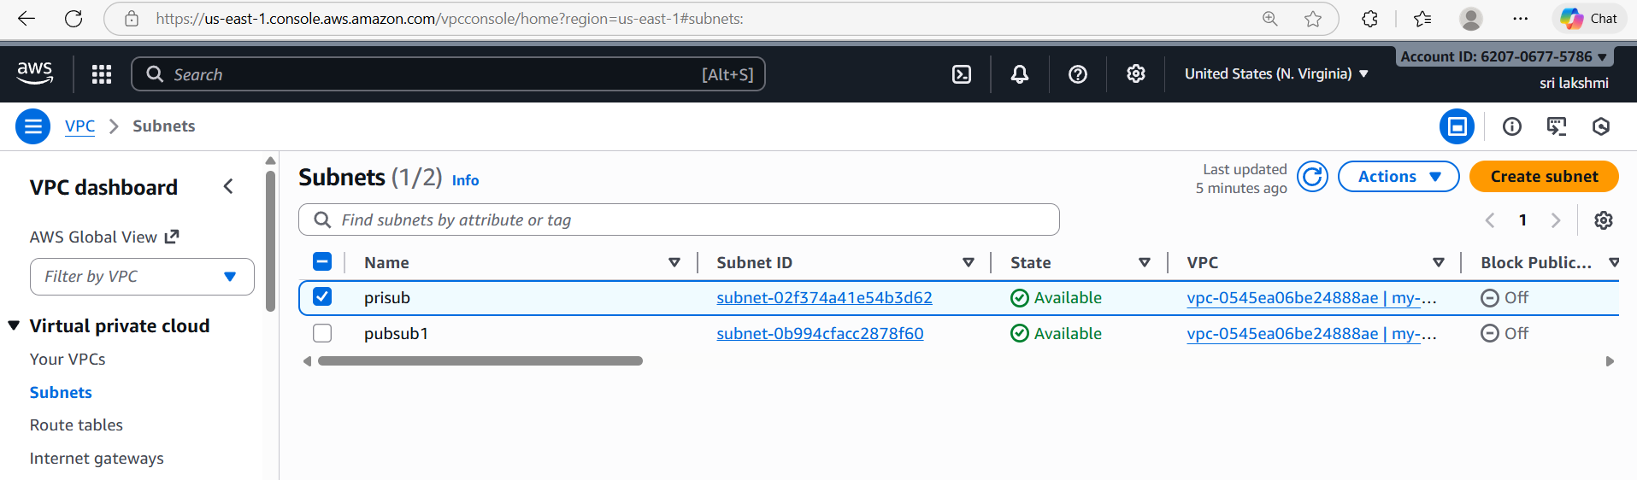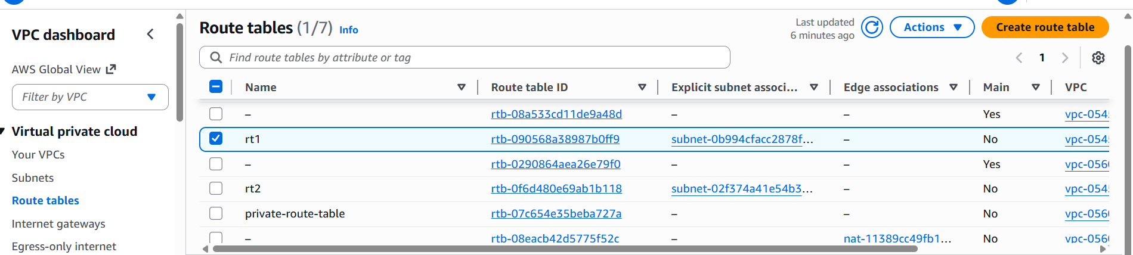
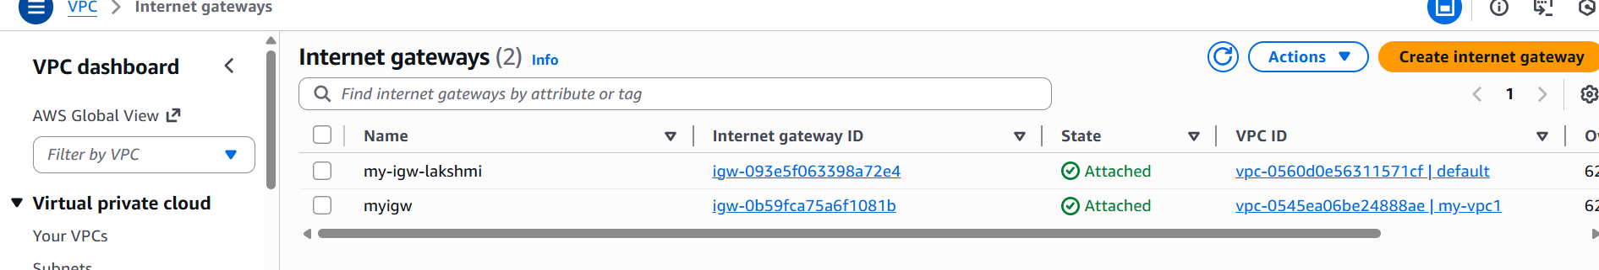
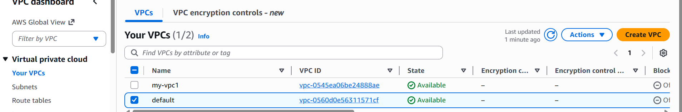
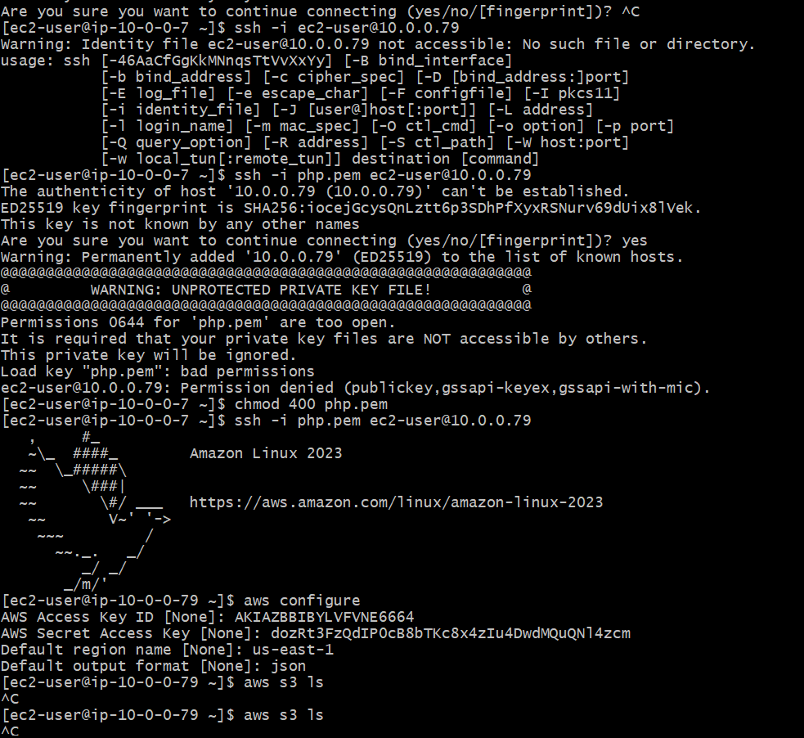
- edit route table for public-->add route 0.0.0.0/0 target internet gateway
create 2 ec2 instances public and private one with public subnet and one with private subnetconnect to public ec2 insatance
Go to root sudo su -
aws configure
crate IAM user and generate key and password
give the access key and password, region and format
use command "aws s3 ls" to see the s3 logs
create a file and paste the pem key of public instance
Now login with private instance ip with in the same server
use command "aws s3 ls"-->command will not excuste because we have created any endpoint.Go to endpoint service create endpoint by selecting gteaway, adding s3-service-region, vpc and route table to private.check in CLI with "aws s3 ls" the s3 logs will be available.

2. Configure VPC endpoints to securely access AWS services without internet gateways or NAT gateways, ensuring data privacy and minimizing exposure to external threats.

Go to VPC Console
AWS Console → VPC → Endpoints → Create endpoint

- Select Gateway
- Choose your VPC
- Choose your Route Tables
Interface (for all other services)
- Select Interface
- Choose your VPC
- Select Private Subnets
- Select a Security Group
- Enable Private DNS (recommended)

